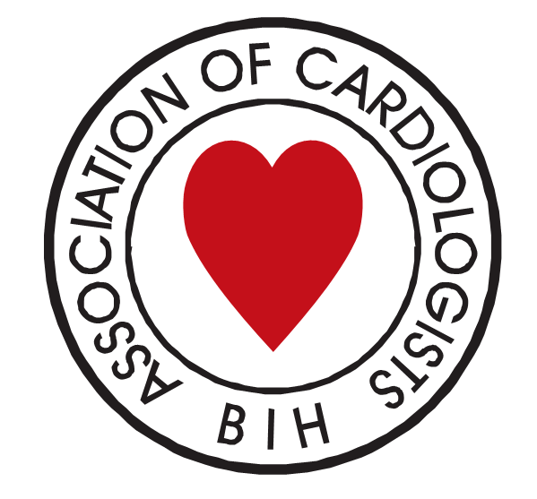
Udruženje kardiologa Bosne i Hercegovine
Udruženje kardiologa HNK/Ž

Internacionalna akademija nauka
i umjetnosti u Bosni i Hercegovini

INTERNACIONALNI NAUČNI SIMPOZIJUM (WEBINAR)
Srčana slabost - Novine sa ESC/AHA kongresa 2023
Heart failure - News from ESC/AHA congress 2023
WORLD HEART DAY / SVJETSKI DAN SRCA 2023. - MOSTAR
Datum i vrijeme / Date and time  petak, 29.09.2023. 18:00h – 21:15h | Prijava za učešće i link za pristup simpozijumu / Registration and access webinar  www.ukhnk.org Registracija najkasnije / Deadline for registration: 29.09.2023. 18h

Organizator / Organizer | Pokrovitelj / Patron
- Udruženje kardiologa HNK/Ž  - Radna grupa za Aterosklerozu UKBiH,  - Radna grupa za Bazična istraživanja u kardiologiji UKBiH,  - Radna grupa za Naprasnu smrt UKBiH  - Radna grupa za Rehabilitaciju KVB UKBiH | - Internacionalna akademija nauka i umjetnosti u Bosni i Hercegovini (IANUBIH)  - Vijeće kongresa bošnjačkih intelektualaca (VKBI)  - Ministarstvo za zdravstvo i socijalnu zaštitu HNK/Ž  - Zavod zdravstvenog osiguranja HNK/Ž  - Liječnička/Ljekarska komora HNK/Ž  - Komora medicinskih sestara i tehničara HNK/Ž

Suorganizator / Co-Organizer | Voditelj / Moderator
- Internacionalna akademija nauka i umjetnosti u Bosni i Hercegovini (IANUBIH) | Emir Fazlibegović, BiH / Emir Veledar, USA

Radno predsjedništvo / Chair persons
Ivan Knezović | Adis Muslibegović | Samra Međedović
17,30 - 18,00 | Registracija učesnika na on-line webinar Microsoft Teams platforma - www.ukhnk.org
18,00 - 18,05 | Otvaranje simpozijuma (pozdravna riječ predstavnika pokrovitelja) / Opening symposium
18,05 - 18,25 | Who should be Screened for HFpEF? All Hypertensive Patients?  Çetin EROL, EFESC, Ankara, Turkey
18,25 - 18,45 | Stress and heart disease  Arshad Quyyumi, AHA,Atlanta, USA
18,45 - 19:00 | Disparities in Diagnostic Modalities, Treatment and Outcomes in Women with Acute Coronary Syndrome  Mahdi Garelnabi, FAHA, Massachusetts Lowell, USA.
19,00 - 19,15 | Adverse Outcomes in Hospitalizations for Amyloid-Related Heart Failure  Muni Rubens,AHA, Miami, USA
19,15 - 19,30 | ChatGPT and guideline-directed surgical treatment suggestions for valvular disease  Peter McGranaghan, AHA, Miami, USA
19,30 - 19,45 | The impact of the Coronavirus disease 2019 on hospitalizations for coronary artery revascularization: results from California State Inpatient Database  Anshul Saxena,AHA, Miami, USA
19,45 - 19,55 | Applying machine learning in cardiovascular risk prediction; moving beyond regression techniques to address analytic challenges.  Emir Veledar, AHA, IANUBIH, Miami, USA
19,55 - 20,05 | Novine sa ESC kongresa 2023 / News from ESC Congress 2023  Emir Fazlibegović, FESC, IANUBIH, Mostar, Bosna i Hercegovina
20,05 - 20:15 | Genetičari dobitnici priznanja Zlatne medalje ESC 2023 / Geneticists who have won the Gold Medal of the ESC 2023  Samra Mededovic, ESC, Mostar, Bosna i Hercegovina
20,15 - 20,25 | ESC Vodič 2023 Kardiomiopatije - ESC Guidelines 2023 Cardiomyopathies  Adis Muslibegović, ESC, Mostar, Bosna i Hercegovina
20,25 - 20,35 | ESC Vodič 2023 Endokarditis - ESC Guidelines 2023 Endocarditis  Benjamin Palić, ESC, Mostar, Bosna i Hercegovina
20,35 - 20,45 | ESC Vodič 2023 Akutni koronarni sindrom - ESC Guideline 2023 Acute coronary syndrome  Omer Manov, Zrinko Prskalo,ESC, Mostar, Bosna i Hercegovina
20,45 - 20,55 | ESC Vodič 2023 Diabetes mellitus - ESC Guidelines 2023 Diabetes mellitus  Danijela Ćuk, ESC, Mostar, Bosna i Hercegovina
20,55 - 21,05 | Povezanost stresa sa somatskim bolestima / The connection between stress and somatic diseases  Dragan Babić, IANUBIH, Mostar, Bosma i Hercegovina
21,05 - 21,15 | Endoskopski zahvati i antikoagulantna terapija / Endoscopic procedures and anticoagulant therapy  Milenko Bevanda, IANUBIH, Mostar, Bosna i Hercegovina

